Let us find the maximum value of function f(x) = 15x – x2, where parameter x varies between 1 to 15. For simplicity, we may assume that x only takes integer value. Thus, table below shows the possible chromosomes that build with only four genes.

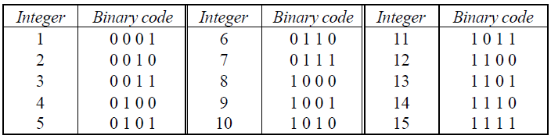

Traveling salesman problem (TSP) is a classic problem which you have to solve the shortest route in order the salesman visit each city. Below are the maps of the city which the salesman has to visit. Create 6 chromosomes to represent the route which the salesman has to travel and evaluate the fitness for each chromosome.

